Data Analytics & Generative AI Internship
A Project Report submitted to the
GLOBAL NEXT CONSULTING INDIA PVT LTD
(Summer Internship Program)
By
Prayas Palit
Under the Supervision of

Ms. Anuradha Gupta
(Project Director)

Submitted To :

Global Next Consulting India Pvt. Ltd.

Duration of Internship :

1 June 2026 to 19 July 2026



July 2026
C
CANDIDATE'S DECLARATION

I, Prayas Palit, hereby declare that the work presented in this report, covering all weekly projects and the final project completed during my internship at Global Next Consulting India Pvt. Ltd. (GNCIPL), is the result of original work carried out by me under the guidance of Ms. Anuradha Gupta during the internship period from 1 June 2026 to 19 July 2026.
I further declare that this report represents an authentic record of my own work and does not contain any falsely fabricated ideas, data, facts, or sources. I also declare that I have adhered to all principles of academic honesty and integrity and that this report has not been submitted, either in part or in full, to any other institute, university, or organization for the award of any degree, diploma, or certification.

Prayas Palit

CERTIFICATE

This is to certify that the project report entitled "Data Analytics & Generative AI Internship Report" has been carried out by Prayas Palit, an Intern in the AI/ML domain, as the complete body of work — five weekly projects and one final project — for the summer internship with Global Next Consulting India Pvt. Ltd. from 1 June 2026 to 19 July 2026. This work was carried out under the guidance of Ms. Anuradha Gupta. It is further certified that this work has not been submitted to any other university or institution for the award of any other degree, diploma, or certificate.

Ms. Anuradha Gupta
Program Director
GNCIPL

ACKNOWLEDGEMENT

I take this opportunity to express my sincere gratitude to all those who contributed to the successful completion of this internship and this report.
I would like to express my sincere gratitude to my supervisor, Ms. Anuradha Gupta, for their invaluable guidance, encouragement, and constructive suggestions throughout the course of this internship. Their expertise and constant support played a crucial role in the successful completion of every project in this report.
I would also like to specially thank Vansh sir for his continuous guidance, technical support, and encouragement throughout the internship, which greatly helped me understand each project topic more clearly and complete my work with confidence.
I am also thankful to the staff of Global Next Consulting India Private Limited for providing the necessary resources, facilities, and their assistance, without which this internship would not have been possible.
Finally, I would also like to acknowledge my peers and mentors whose support and discussions have been helpful throughout this internship.

Prayas Palit

ABSTRACT

This report presents the complete body of work from my six-week AI/ML internship at Global Next Consulting India Pvt. Ltd., spanning five weekly mini-projects and one final capstone project, each applying a different stage of the data science and machine learning workflow to a different real-world dataset.
Week 1 applied data-cleaning and exploratory analysis to a real PhishTank cybersecurity feed of 63,956 reported phishing URLs. Week 2 conducted an exploratory analysis of COVID-19 vaccination coverage trends across four countries using public Our World in Data records. Week 3 used K-Means clustering to segment 200 mall customers by age and spending behaviour. Week 4 applied a more advanced unsupervised pipeline — PCA, t-SNE, tuned K-Means, and hierarchical clustering — to segment 1,381 Last.fm listeners into eight music-taste groups. Week 5 built and trained an Artificial Neural Network in TensorFlow/Keras to classify real Stanford ACL IMDB movie reviews as positive or negative, reaching 73.6% test accuracy.
The final project addressed a core challenge in financial fraud detection: extreme class imbalance in real-world transaction data, where genuine fraud cases make up less than 0.2% of all transactions. Using the genuine Kaggle Credit Card Fraud dataset (284,807 transactions, 492 real fraud cases), the project tested whether Generative-AI-based synthesis of the minority fraud class — via a Gaussian Copula generative model — improves a Random Forest fraud classifier, using a rigorous, leak-free evaluation methodology throughout.
Across all six projects, this internship built practical skills in data cleaning, exploratory data analysis, unsupervised learning, deep learning for natural language processing, generative AI, and rigorous model evaluation — along with the professional skills needed to document and present technical work clearly to both technical and non-technical audiences.

INDEX

Candidate's Declaration
Certificate
Acknowledgement
Abstract
Chapter 1: Introduction
1.1 Company's Profile
1.2 Objectives of Internship
Chapter 2: The Projects
2.1 Week 1 – Phishing Incident Report Analysis
2.2 Week 2 – COVID-19 Vaccine Efficacy Trends (EDA)
2.3 Week 3 – Age vs. Spending Cluster Analysis
2.4 Week 4 – Music Listener Segmentation
2.5 Week 5 – Movie Review Sentiment Analysis
2.6 Major Project – Enhancing Fraud Detection Using Synthetic Transactions Generated by Gen AI
Chapter 3: Methodology
3.1 Tools and Techniques Used
3.2 Data Sources and Collection
3.3 Data Cleaning and Preprocessing
3.4 Visualisation Techniques
Chapter 4: Results and Discussion
4.1 Insights from Weekly Projects
4.2 Skills Gained
Chapter 5: Conclusion
5.1 Overall Learning Outcomes
5.2 Applications of Work
Internship Certificate
Summary
References
Chapter 1- Introduction
1.1 Company's Profile
Global Next Consulting India Private Limited (GNCIPL), headquartered in Greater Noida, Uttar Pradesh, is a cybersecurity-focused consulting firm dedicated to helping organizations protect their digital assets, data, and reputation. As threats evolve in today's digital world, GNCIPL offers proactive, customized solutions rather than reactive fixes. The company serves clients in diverse sectors including finance, healthcare, manufacturing, and technology, providing services like threat detection, risk assessment, incident response, compliance consulting, and 24/7 monitoring. GNCIPL's core values are integrity, innovation, customer-centricity, excellence, and collaboration — ensuring that technical solutions align with clients' specific needs and long-term goals.
Contact Details
Location – B5,402 P4 PHi2, CGEWHO TOWER, GREATER NOIDA 201310
Contact Numbers – 0120-4001768, +91-9315504902, +91-7666141260
Mail – hr@gncipl.com
1.2 Objectives of Internship
Over six weeks at GNCIPL as an AI-ML Intern, one new project topic was assigned each week, moving from foundational data handling towards more advanced modelling. The main objectives were:
- To build a solid foundation in data cleaning, exploratory data analysis, and visualization using real, publicly sourced datasets across different domains — cybersecurity, public health, retail, and music streaming.
- To progress from foundational EDA towards applied machine learning: unsupervised clustering and segmentation, and deep learning for natural language processing.
- To gain hands-on experience with generative AI techniques for tabular data synthesis in the final project, addressing a real class-imbalance problem in financial fraud detection.
- To learn end-to-end, rigorous ML workflow: preprocessing, modelling, and honest, leak-free evaluation, rather than reporting only the most favourable metric.
- To enhance analytical thinking, technical documentation, and presentation skills through six structured project deliverables — notebooks, presentations, and this consolidated report.
Chapter 2 – The Projects
2.1 Week 1 – Phishing Incident Report Analysis
2.1.1 Introduction
Phishing remains one of the most common attack vectors in cybersecurity, and organizations increasingly rely on crowdsourced threat-intelligence feeds to track active phishing campaigns. This project worked with a real feed from PhishTank, a community-driven database of verified phishing URLs, to clean the raw data and extract early operational insight — which brands are targeted most, and what these malicious URLs typically look like.
2.1.2 Objectives
- Load and quality-check a real, 63,956-row PhishTank export (phish ID, URL, submission time, verification status, and impersonated brand/target).
- Identify and remove duplicate records to produce an analysis-ready cleaned dataset.
- Determine which brands are impersonated most often, and characterize the length distribution of phishing URLs.
2.1.3 Methodology
a) Data Loading and Quality Checks
- Loaded the raw PhishTank export (63,956 rows, 7 columns: phish_id, url, phish_detail_url, submission_time, verified, verification_time, online, target).
- Checked for missing values (none found) and inspected data types and value ranges.
b) Deduplication
- Checked for fully duplicated rows (none found) and duplicate URLs specifically (7 found) — removed to leave 63,949 clean, unique records.
c) Exploratory Analysis
- Counted phishing reports by impersonated brand (“target” field), excluding the generic “Other” category, to find the most-imitated organizations.
- Computed URL length for every record and visualized its distribution to characterize typical vs. extreme phishing URL structures.
2.1.4 Results and Insights
a) Dataset Overview
- 63,956 raw records → 63,949 after removing 7 duplicate URLs (99.99% already unique).
- Zero missing values across all fields.

b) Most-Impersonated Brands
Rank | Target Brand | Phishing Reports
1 | Allegro | 1,736
2 | Internal Revenue Service (IRS) | 832
3 | Facebook | 347
4 | Microsoft | 273
5 | Bradesco | 243

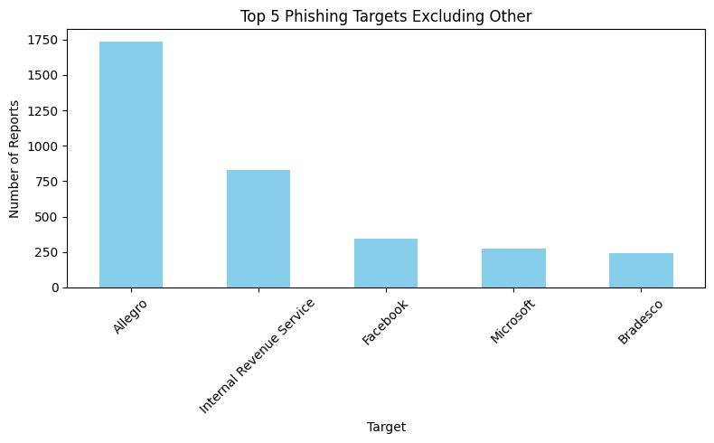
Fig 2.1.1 – Top 5 impersonated brands by phishing report count.
c) URL Length Distribution
Mean URL length was 57.99 characters (std. dev. 158.41), with a minimum of 12 and a maximum of 25,523 characters — an extreme outlier suggesting obfuscation techniques (long encoded query strings) used to evade basic length-based filters.
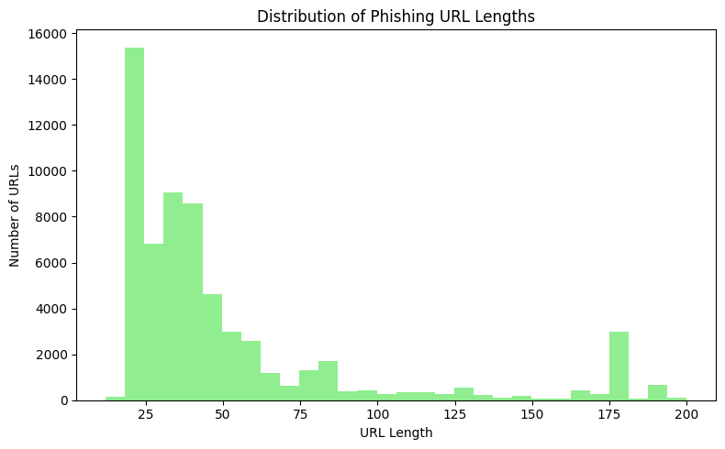
Fig 2.1.2 – Distribution of phishing URL lengths (capped at 200 characters for readability).

2.1.5 Recommendations
- Prioritize brand-protection monitoring for the most-impersonated targets (Allegro, IRS, Facebook, Microsoft, Bradesco), since these concentrate a disproportionate share of reported phishing activity.
- Treat unusually long or obfuscated URLs as a useful, low-cost heuristic feature for a future automated phishing-detection model.
2.1.6 Conclusion
This first-week project established foundational data-cleaning and exploratory-analysis skills on a real, messy cybersecurity dataset. Even without predictive modelling, the cleaned data and brand/URL-length insights provide directly actionable intelligence for prioritizing phishing-defense efforts.

2.2 Week 2 – COVID-19 Vaccine Efficacy Trends (EDA)
2.2.1 Introduction
Tracking vaccination rollout speed and coverage is central to public-health decision-making. This project performed an exploratory analysis of COVID-19 vaccination trends across four countries — India, the United States, Brazil, and Japan — using public vaccination records from Our World in Data, to compare rollout pace and coverage over time.
2.2.2 Objectives
- Clean and prepare country-level daily vaccination records for reliable time-series comparison.
- Compare vaccination coverage and rollout trends across the four selected countries.
- Identify which countries led or lagged in vaccination coverage, and examine correlations between vaccination metrics.
2.2.3 Methodology
a) Data Cleaning
- Filtered the global dataset to the four target countries (3,604 records) and handled missing values with forward-fill then backward-fill per country, clipping percentage fields to a valid 0–100 range.
b) Feature Engineering
- Derived year, month, and days-since-start features from the date column to support trend and seasonality analysis.
c) Visualization and Encoding
- Produced country-level summary statistics and eight visualizations; applied label encoding and one-hot encoding to the country field for correlation analysis.
2.2.4 Results and Insights
a) Latest Vaccination Coverage by Country
At each country's most recent reporting date, Brazil showed the highest “fully vaccinated” share (83.77%), while India's snapshot stood at 66.79% — though countries' data collection windows ended at different dates, so this reflects each country's latest available reading rather than a single fixed date.
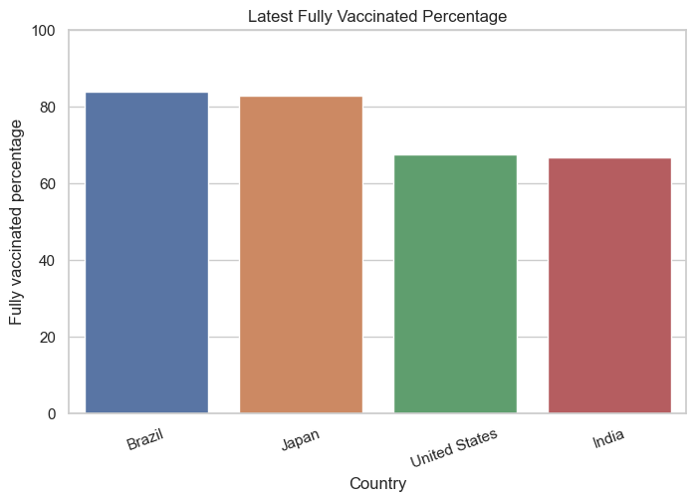
Fig 2.2.1 – Latest fully-vaccinated percentage by country.
b) Vaccination Trend Over Time
Time-series plots showed steadily rising vaccination coverage in all four countries, with differing rollout speeds — useful for identifying which country's campaign scaled fastest in its early months versus which sustained momentum longest.
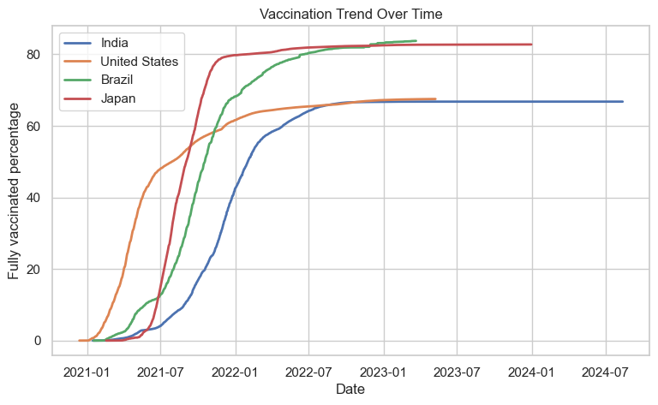
Fig 2.2.2 – Vaccination coverage trend over time by country.
c) Average Coverage and Correlation
Averaged across the full time series (not just the latest date), Japan led with a 64.61% mean fully-vaccinated rate, while India's mean stood at 49.82% — the lowest of the four. A correlation heatmap of the engineered features confirmed the expected strong positive relationship between days-since-start and cumulative vaccination coverage.
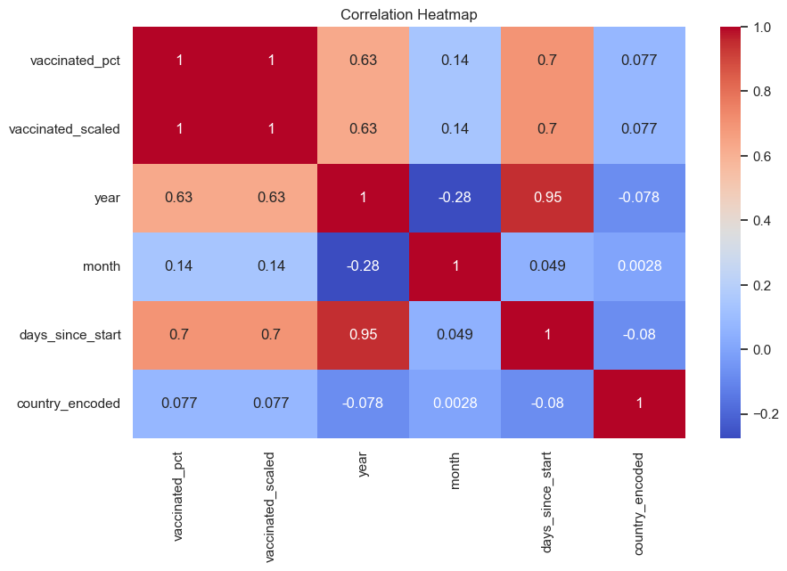
Fig 2.2.3 – Correlation heatmap of vaccination and time-based features.
2.2.5 Recommendations
- Countries with slower average rollout (e.g., India in this sample) may benefit from case studies of faster-scaling campaigns (e.g., Japan, Brazil) to identify transferable logistics or policy practices.
- Because the four countries' data windows end on different dates, any cross-country comparison for policy purposes should re-align on a common reporting date rather than each country's own latest snapshot.
2.2.6 Conclusion
This project demonstrated a complete public-health EDA workflow — missing-value handling appropriate to time-series data, feature engineering, and multi-country comparative visualization — and surfaced clear, actionable differences in vaccination rollout pace and coverage across the four countries studied.

2.3 Week 3 – Age vs. Spending Cluster Analysis
2.3.1 Introduction
Customer segmentation is a foundational retail and marketing analytics technique: grouping customers by shared behavioural traits enables targeted, cost-effective marketing rather than one-size-fits-all campaigns. This project applied K-Means clustering to the classic Mall Customer dataset (200 customers) to segment shoppers by age and spending behaviour.
2.3.2 Objectives
- Explore the demographic and spending profile of 200 mall customers (Gender, Age, Annual Income, Spending Score).
- Determine a statistically justified number of customer segments using the Elbow Method and Silhouette Score.
- Profile each resulting segment and translate the clusters into actionable marketing personas.
2.3.3 Methodology
a) Data Preparation
- Verified data quality (no missing values, no duplicates in this 200-row dataset); dropped the non-informative CustomerID column.
b) Feature Scaling
- Selected Age and Spending Score as clustering features and applied StandardScaler to place both on a comparable scale.
c) Optimal Cluster Selection
- Evaluated K = 2 through 10 using both the Elbow Method (inertia) and Silhouette Score; selected K = 4 as a balance between statistical fit and the number of practically actionable, distinct customer personas.
d) K-Means Clustering
- Fit the final K-Means model with K = 4 and profiled each cluster's average age, income, and spending score.
2.3.4 Results and Insights
a) Demographic Overview
Cluster | Avg. Age | Avg. Income (k) | Avg. Spending Score | Persona
0 | 27.2 | 59.6 | 40.0 | Young, moderate spenders
1 | 30.3 | 63.8 | 79.8 | Young, high spenders
2 | 47.6 | 63.8 | 15.0 | Mature, low spenders
3 | 56.0 | 54.4 | 48.5 | Mature, moderate spenders
- 112 female and 88 male customers in the dataset.
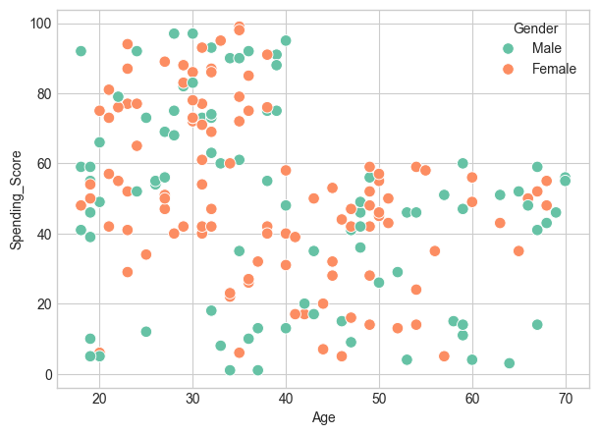
Fig 2.3.1 – Age vs. Spending Score, coloured by gender.
b) Choosing K = 4
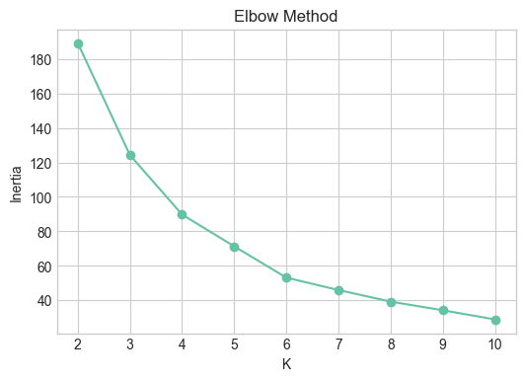
Fig 2.3.2 – Elbow method used to select the number of clusters.
c) Four Customer Segments

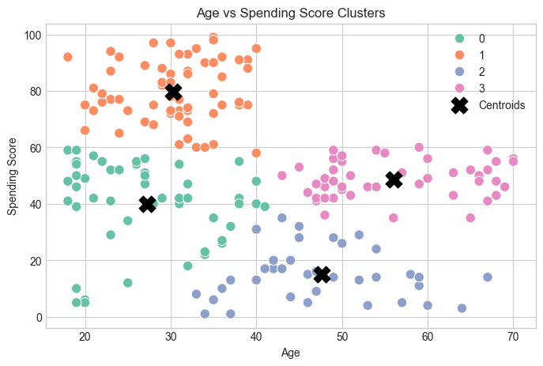
Fig 2.3.3 – Final four customer clusters with centroids.
2.3.5 Recommendations
- Young high spenders: prioritize for premium offerings, early access, and loyalty programs given their strong existing spend.
- Young moderate spenders: target with promotions and incentives designed to grow their spend toward the high-spender segment.
- Mature moderate spenders: focus on retention — this group is stable but not growing; loyalty and consistency-oriented offers fit well.
- Mature low spenders: consider reactivation campaigns to understand and address the barriers keeping their spend low.
2.3.6 Conclusion
This project delivered a complete, statistically grounded customer-segmentation pipeline — from feature scaling and cluster-count justification through to business-ready personas — directly transferable to real retail marketing decisions.

2.4 Week 4 – Music Listener Segmentation

2.4.1 Introduction
Streaming platforms rely heavily on listener segmentation to power personalized recommendations. This project applied a more advanced unsupervised-learning pipeline to the Last.fm (hetrec2011) listening-history dataset, segmenting 1,381 listeners into distinct taste groups based on their play counts across the platform's most-played artists.

2.4.2 Objectives
- Build a listener-by-artist play-count matrix for the platform's top artists and normalize it for fair comparison across listeners with very different total activity levels.
- Reduce dimensionality and visualize listener structure using PCA and t-SNE.
- Determine a statistically optimal number of listener segments and validate the clustering with multiple methods.

2.4.3 Methodology
a) Data Preparation
- Filtered ~92,834 raw play-count records down to the 12 most-played artists and built a 1,381-listener × 12-artist matrix; applied a log transform, per-listener rank normalization, and StandardScaler to control for wide swings in individual listening volume.
b) Dimensionality Reduction
- Used PCA to examine explained variance across components, then t-SNE to produce a 2-D visualization of listener similarity structure.
c) Hyperparameter Tuning
- Used GridSearchCV to search K-Means configurations, selecting the model that maximized Silhouette Score while cross-checking with the Davies-Bouldin Index; best result: K = 8, Silhouette = 0.525, Davies-Bouldin = 0.657.
d) Clustering and Validation
- Fit the final K = 8 K-Means model and independently validated cluster structure with agglomerative hierarchical clustering (dendrogram) on a listener sample.

2.4.4 Results and Insights
a) Top Artists by Total Play Count
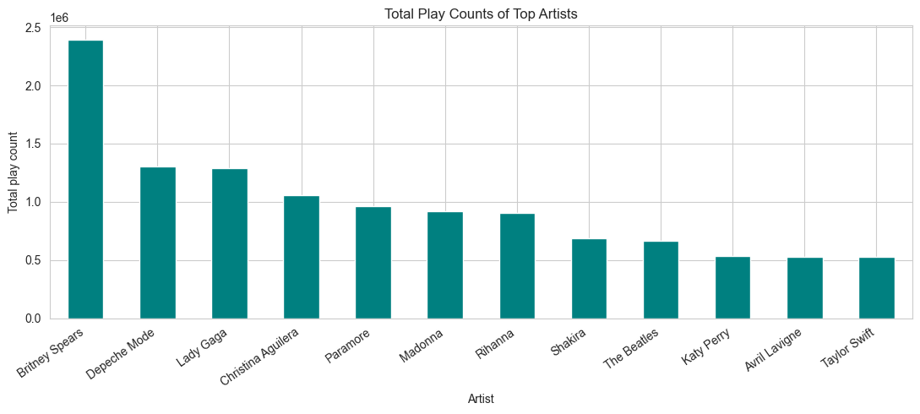
Fig 2.4.1 – Total play counts for the top 12 artists used in segmentation.
b) Eight Listener Segments
Segment (named by top 2 artists) | Listeners
Britney Spears / Christina Aguilera listeners | 280
The Beatles / Britney Spears listeners | 249
Taylor Swift / Britney Spears listeners | 215
Paramore / The Beatles listeners | 197
Lady Gaga / Paramore listeners | 134
Depeche Mode / Paramore listeners | 121
Depeche Mode / Madonna listeners | 115
Depeche Mode / The Beatles listeners | 70

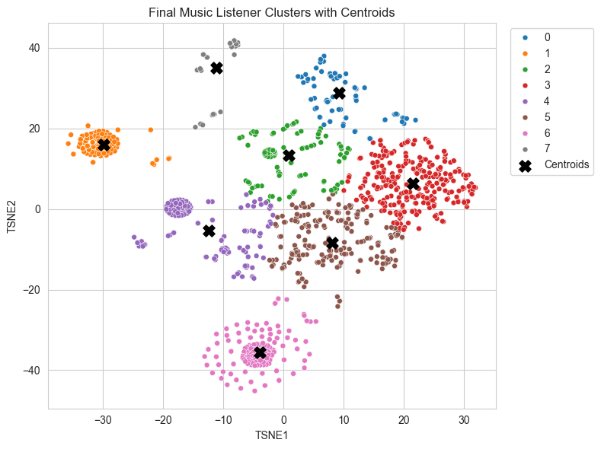
Fig 2.4.2 – Final 8-cluster solution visualized via t-SNE.

c) Cluster Profiles
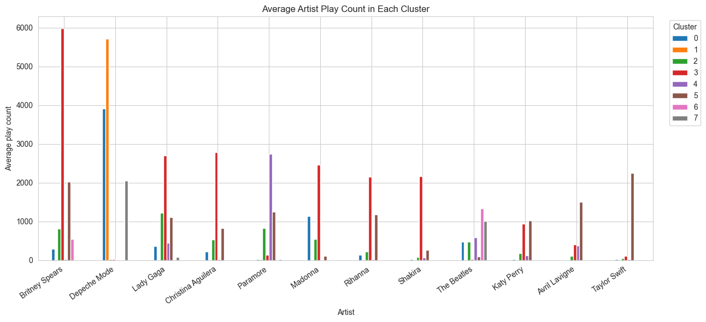
Fig 2.4.3 – Average (rank-normalized) listening profile per cluster.
2.4.5 Recommendations
- Use the eight taste segments directly as candidate audiences for personalized playlist curation and targeted new-release promotion.
- The pop-leaning segments (Britney Spears / Christina Aguilera; The Beatles / Britney Spears) are the largest audiences and merit the broadest promotional reach; smaller, distinct segments (e.g., Depeche Mode / The Beatles) suit niche, high-affinity campaigns instead.
2.4.6 Conclusion
This project applied a materially more advanced unsupervised pipeline than earlier weeks — combining dimensionality reduction, systematic hyperparameter search, and cross-validated clustering — to deliver eight statistically robust, musically coherent listener segments with direct application to personalization and marketing.

2.5 Week 5 – Movie Review Sentiment Analysis
2.5.1 Introduction
Automatically classifying the sentiment of free-text reviews is a widely applicable NLP task, from product feedback triage to content moderation. This project built and trained an Artificial Neural Network (ANN) in TensorFlow/Keras to classify real movie reviews from the Stanford ACL IMDB dataset as positive or negative.
2.5.2 Objectives
- Prepare a balanced set of real IMDB movie reviews for supervised sentiment classification.
- Design and train a neural network capable of learning sentiment directly from raw review text.
- Evaluate the model rigorously — accuracy, precision, recall, F1, and confusion matrix — and identify its practical limitations.
2.5.3 Methodology
a) Data Preparation
- Sampled 4,000 real reviews (2,000 positive, 2,000 negative) from the official Stanford ACL IMDB train/test folders, then split into training, validation, and a held-out 800-review test set.
- Used Keras's TextVectorization layer to tokenize and pad raw review text for direct neural network input.
b) Model Architecture
- Embedding layer (64 dimensions) → GlobalAveragePooling1D → Dense(64, ReLU) → Dropout(0.5) → Dense(32, ReLU) → Dropout(0.3) → Dense(1, Sigmoid) — 646,273 total trainable parameters.
c) Training
- Compiled with the Adam optimizer and binary cross-entropy loss; trained for up to 5 epochs with EarlyStopping on validation loss to prevent overfitting, batch size 32.
2.5.4 Results and Insights
a) Training Performance
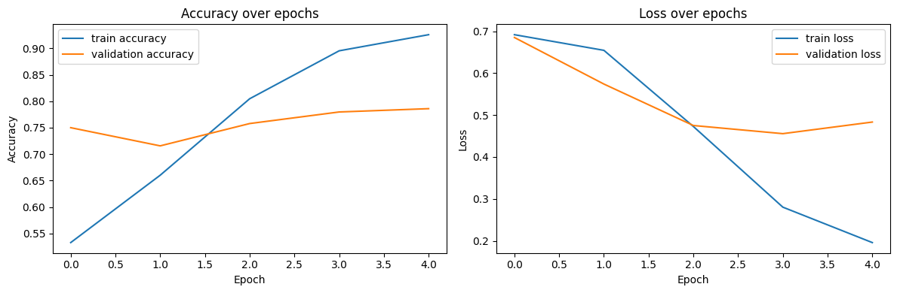
Fig 2.5.1 – Training/validation accuracy and loss curves across epochs.

b) Test Set Performance
Metric | Score
Accuracy | 73.6%
Precision | 89.9%
Recall | 53.3%
F1-Score | 66.9%

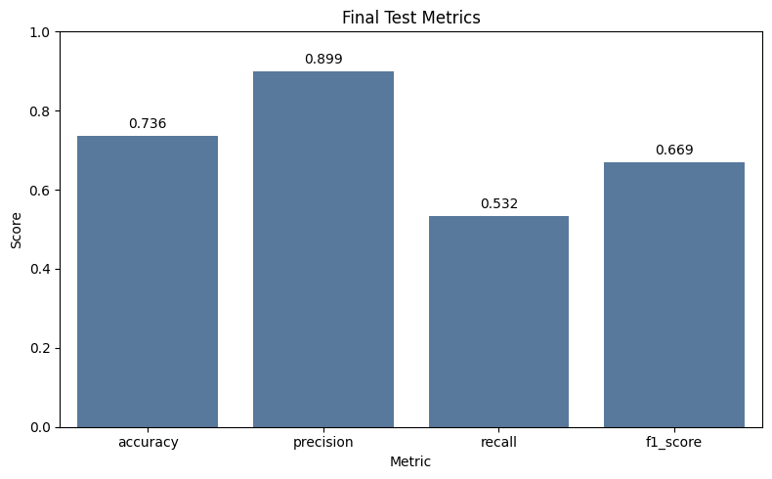
Fig 2.5.2 – Final test-set performance metrics.
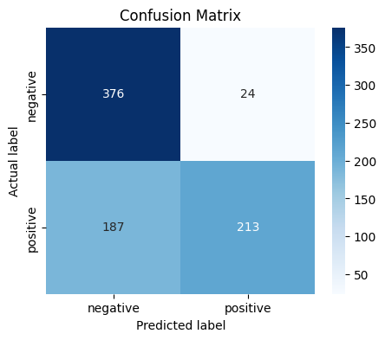
Fig 2.5.3 – Confusion matrix on the 800-review held-out test set.
c) A Practical Limitation Worth Noting
Precision (89.9%) was much higher than recall (53.3%) on the positive class — the model is conservative and tends to under-predict “positive,” missing nearly half of genuinely positive reviews while rarely mislabelling a negative review as positive. A manual test case, “The movie was emotional, funny, and beautifully performed,” was misclassified as negative with high confidence, despite unambiguous positive sentiment — a useful, honest reminder that a respectable aggregate accuracy figure can still hide meaningful blind spots on individual examples.

2.5.5 Recommendations
- Address the precision/recall imbalance by adjusting the classification threshold below 0.5, or by rebalancing the training loss, to raise recall on the positive class.
- Replace the from-scratch embedding layer with pretrained word embeddings (e.g., GloVe) or a pretrained transformer encoder to likely improve both accuracy and generalization to figurative or mixed-sentiment language.

2.5.6 Conclusion
This project delivered a complete deep-learning NLP pipeline — from raw text to a trained, evaluated neural network — and, importantly, looked past the headline accuracy figure to identify a genuine, actionable weakness in the model's recall, mirroring the rigorous, honest evaluation approach applied throughout this internship's final project.

2.6 Major Project – Enhancing Fraud Detection Using Synthetic Transactions Generated by Gen AI
2.6.1 Introduction
Credit card fraud is a textbook extreme-imbalance problem: in the genuine Kaggle “Credit Card Fraud Detection” dataset used for this project, fraudulent transactions make up only 0.173% of all records (492 fraud cases out of 284,807 transactions). A classifier trained naively on data this skewed sees almost no fraud examples during training and, as this project demonstrates, misses a large share of real fraud as a result.
This project tests a proposed remedy from the internship brief's “Data Generation and Augmentation using Generative AI” track: use a generative model to synthesize additional, statistically realistic fraud transactions, add them only to the training data, and measure — rigorously and honestly — whether the resulting classifier actually detects more real fraud.
2.6.2 Objectives
Primary Objectives
- To generate synthetic fraud transactions using a generative AI model and augment the real, imbalanced training data.
- To train a fraud classifier on both the original and the augmented data, and compare performance fairly.
- To evaluate rigorously — with a leak-free train/test split and matched-threshold comparisons — rather than reporting only a single, possibly misleading, default-threshold snapshot.
Specific Analytical Goals
- Quantify the class imbalance and identify the features most correlated with fraud.
- Fit a Gaussian Copula generative model on real fraud transactions and validate its synthetic output against the real distribution.
- Compare a baseline Random Forest (real data only) against an augmented Random Forest (real + synthetic) on precision, recall, F1, and AUC.
- Test whether the technique's benefit changes depending on how much real fraud data is available to begin with.
2.6.3 Methodology
a) Dataset Preparation
- Obtained the genuine Kaggle Credit Card Fraud dataset (284,807 transactions; Time, V1–V28 anonymized/PCA features, Amount, Class).
- Verified data quality: no missing values; 1,081 duplicate rows identified as a known characteristic of this public dataset.
- Split the data into training (199,364 rows, 344 fraud) and test (85,443 rows, 148 fraud) sets — stratified by class — before any synthetic data was introduced.

b) Generative Model — Gaussian Copula
- Used copulas.multivariate.GaussianMultivariate — the statistical technique behind SDV's non-deep-learning tabular synthesizer — in place of CTGAN, since CTGAN's PyTorch dependency exceeded the available disk space in the project environment. Gaussian Copula is explicitly listed as a valid tabular technique in the project brief's own “Choose a Gen AI Method” table.
- Fit the generator only on the 344 fraud rows in the training split — never on the 148 rows held out for testing — to keep the generative model itself leak-free, not just the classifier.
- Sampled 5,000 new synthetic fraud transactions and clipped every feature to the real fraud data's observed range (with a small margin) to remove rare, unrealistic outliers produced by occasional heavy-tailed marginal fits.
c) Model Training and Evaluation Design
- Trained two identical Random Forest classifiers (n_estimators=100, max_depth=16): one on real training data only (“baseline”), one on real + synthetic training data (“augmented”).
- Evaluated both models on the exact same, untouched, 100%-real test set.
- Checked results at the default 0.5 threshold and at matched precision/recall operating points, plus ROC-AUC and Average Precision, to avoid a misleading single-threshold conclusion.
- Re-ran the identical pipeline on an earlier, severely fraud-scarce dataset (80 real training-fraud rows) to test whether the technique's value depends on data scarcity.
2.6.4 Results and Insights
a) Dataset Overview
• Total transactions: 284,807
• Fraud cases: 492 (0.173%)
• Imbalance ratio: 1 : 577
• Most fraud-correlated features: V17, V14, V12, V10
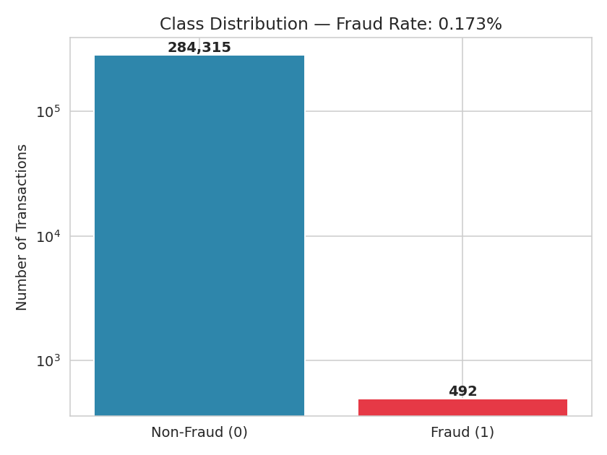
Fig 2.6.1 – Class distribution (log scale).

b) Default-Threshold Comparison
Evaluated on the identical, real-only test set, at the classifier's default 0.5 threshold:
Model | Precision | Recall | F1-Score | AUC
Baseline (Real data only) | 0.957 | 0.757 | 0.845 | 0.967
Augmented (Real + Synthetic) | 0.830 | 0.824 | 0.827 | 0.969

Recall improved by +6.8 percentage points (75.7% → 82.4%), but F1 dipped slightly (-1.8 points) as precision fell — a genuine trade-off, not a clean win.
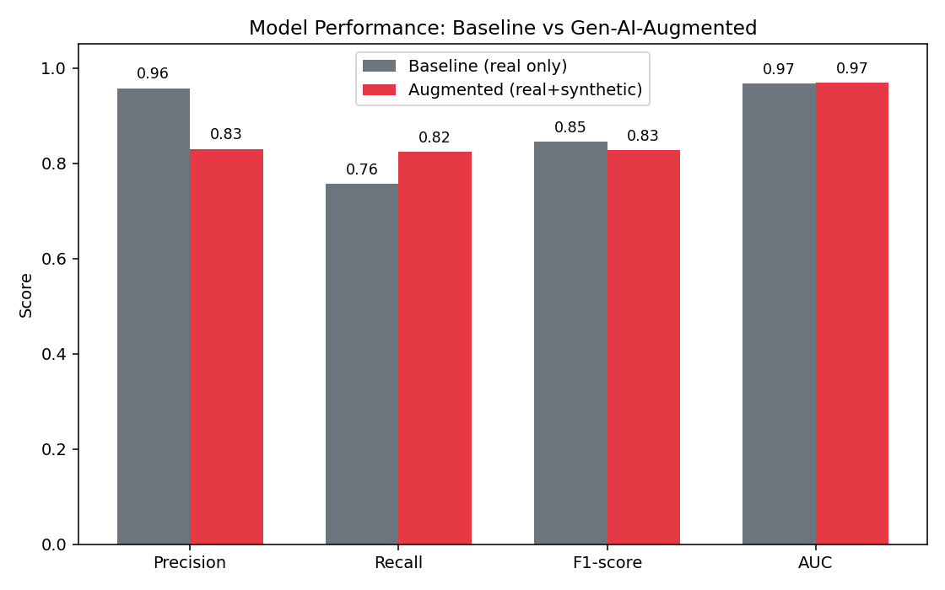
Fig 2.6.2 – All four metrics at the default threshold.
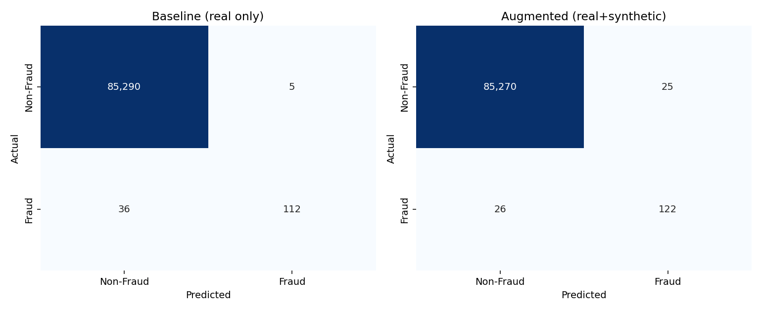
Fig 2.6.3 – Confusion matrices: baseline catches 112/148 fraud cases, augmented catches 122/148.
c) A Fairer Comparison — Matched Thresholds
Comparing models only at their own default threshold can mislead, since a model tuned toward recall will show higher recall almost by construction. At matched operating points, the picture is more even-handed:
- Recall at baseline's precision (0.957): augmented achieves 0.716 vs. baseline's own 0.757.
- Precision at baseline's recall (0.757): augmented achieves 0.913 vs. baseline's own 0.957.
- Average Precision (PR-AUC): 0.822 (baseline) vs. 0.819 (augmented) — essentially a wash.
- ROC-AUC: 0.967 (baseline) vs. 0.969 (augmented) — only a marginal edge.
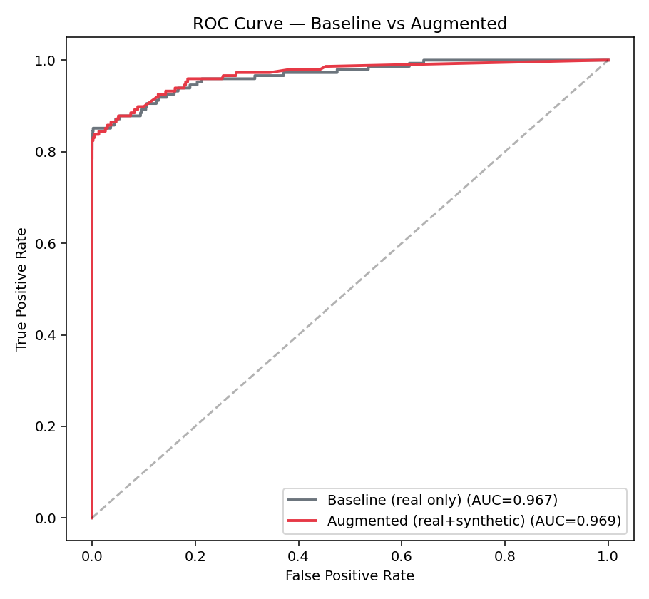
Fig 2.6.4 – ROC curve: AUC improves only marginally.
d) Does Augmentation's Value Depend on Data Scarcity? Yes.
Comparing this run (344 real training-fraud rows) against an earlier run of the identical pipeline under severe scarcity (80 real training-fraud rows, via a simulated dataset built before the genuine data became accessible) isolates the effect of data scarcity:
Scarcity Condition | Real Fraud Rows | Recall Gain | F1 Gain
Severe scarcity (earlier run) | 80 | +44.1 pts | +18.9 pts
Moderate data (this project) | 344 | +6.8 pts | -1.8 pts

Synthetic augmentation delivers its clearest, most dramatic wins when real examples are extremely scarce; its benefit shrinks — and can become inconsistent — once several hundred real examples are already available for the classifier to learn from directly.
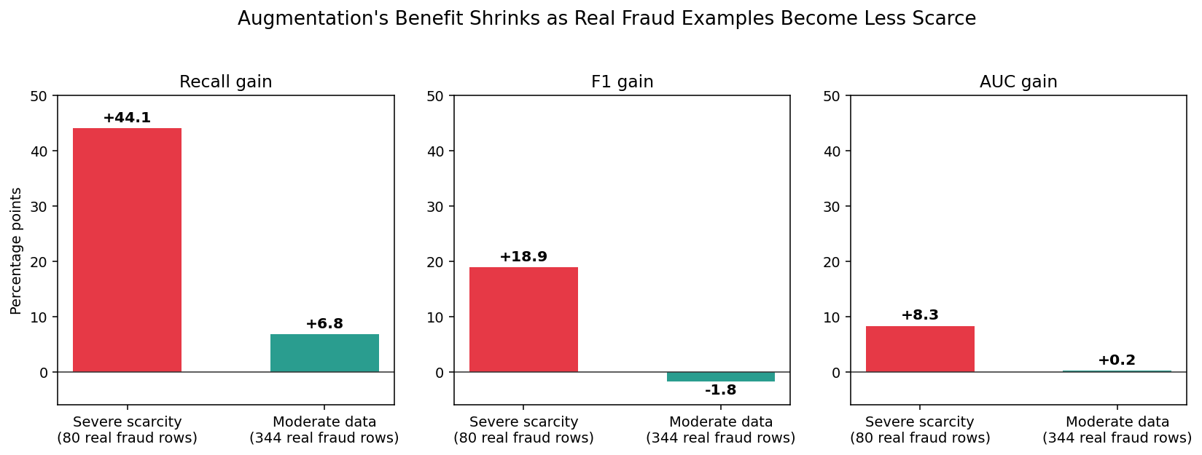
Fig 2.6.5 – Augmentation's benefit shrinks as real fraud examples become less scarce.
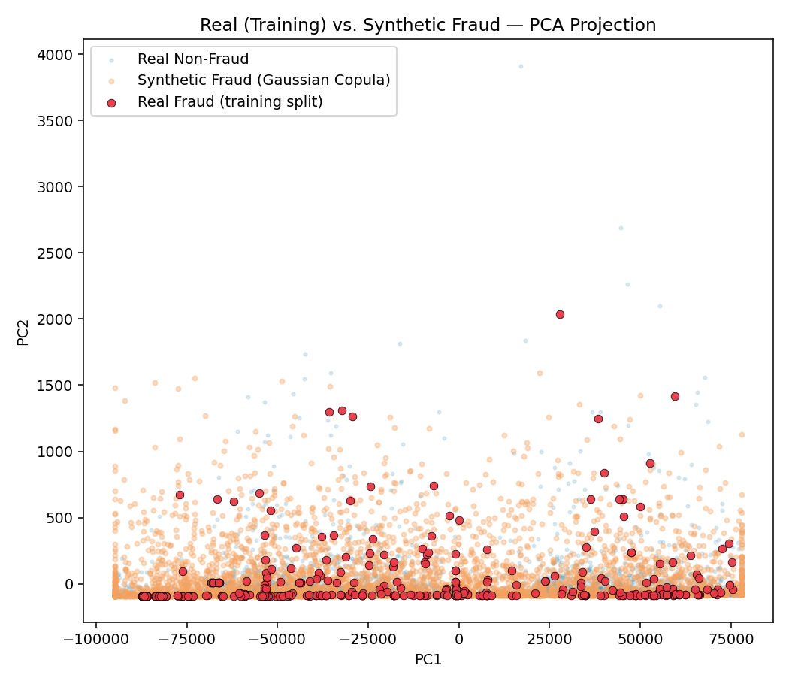
Fig 2.6.6 – Synthetic fraud (orange) lands inside the real fraud cluster (red), validating synthesis quality.
2.6.5 Recommendations
- Use synthetic minority-class augmentation confidently when real fraud examples number in the tens; validate carefully (matched-threshold and AUC/PR-AUC, not just default-threshold metrics) once real examples number in the hundreds.
- Where disk/GPU budget allows, test true CTGAN/TVAE (via the sdv package) against Gaussian Copula — the moderate-data result here was close enough that a higher-fidelity generator could plausibly tip it favourably.
- Tune the classification decision threshold to the business's real cost ratio between a false positive and a missed fraud, rather than relying on the default 0.5 cutoff.
- Always fit generative models on the training split only — never on data that includes anything held out for evaluation.
2.6.6 Conclusion
This project rigorously tested whether generative-AI-based data augmentation improves fraud detection, using the genuine Kaggle Credit Card Fraud dataset with a leak-free methodology at every stage. With 344 real fraud examples already available for training, Gaussian-Copula-based augmentation produced a genuine but modest and mixed effect: a meaningful recall gain offset by a precision and F1 dip, and essentially no improvement in Average Precision. Compared against the severe-scarcity run, the pattern is clear: this technique's value depends heavily on how much real data already exists, and is most worth deploying when real examples are extremely scarce — a more useful and defensible conclusion than a single-scenario success story would have been.

2.6.7 Key Takeaways
- Fraud is a genuinely rare event (0.173%) — real fraud examples alone are often too few to train a strong classifier.
- A leak-free evaluation methodology (test set held out before synthesis; generator fit on training data only) is essential for a trustworthy result.
- Default-threshold metrics alone can be misleading — matched-threshold and AUC/PR-AUC comparisons are needed for a fair verdict.
- Synthetic augmentation's value is scarcity-dependent: dramatic under severe scarcity, marginal once moderate real data exists.
- Gaussian Copula is a fast, GPU-free, and genuinely useful substitute for CTGAN on small-to-moderate tabular generation tasks.
Chapter 3 – Methodology
3.1 Tools and Techniques Used
Category | Tools / Techniques
Language | Python 3 (Jupyter Notebooks)
Data handling | Pandas, NumPy
Unsupervised learning | K-Means, Agglomerative Hierarchical Clustering, PCA, t-SNE, GridSearchCV, Silhouette Score, Davies-Bouldin Index
Deep learning / NLP | TensorFlow, Keras (TextVectorization, Embedding, Dense, Dropout layers)
Generative modelling | Gaussian Copula (copulas.multivariate.GaussianMultivariate) — CTGAN-class technique
Classification | Scikit-learn (RandomForestClassifier)
Evaluation | Precision, Recall, F1, ROC-AUC, Average Precision, Silhouette/Davies-Bouldin, matched-threshold analysis
Visualization | Matplotlib, Seaborn (bar/line/box plots, heatmaps, PCA/t-SNE scatter plots, dendrograms, confusion matrices, training curves)
Documentation | Jupyter Notebooks, Microsoft Word, PowerPoint

3.2 Data Sources and Collection
- Week 1: PhishTank — a crowdsourced, community-verified database of reported phishing URLs (63,956 records).
- Week 2: Our World in Data — public COVID-19 vaccination records for India, the United States, Brazil, and Japan.
- Week 3: The Mall Customer Segmentation dataset — 200 customer records (Age, Annual Income, Spending Score).
- Week 4: Last.fm (hetrec2011) listening-history dataset from GroupLens — artist play counts for 1,381 listeners.
- Week 5: The Stanford ACL IMDB Large Movie Review dataset — real, human-labelled positive and negative movie reviews.
- Major Project: the genuine Kaggle “Credit Card Fraud Detection” dataset — 284,807 anonymized European cardholder transactions, obtained via a GitHub-hosted mirror.

3.3 Data Cleaning and Preprocessing
- Missing-value and duplicate checks were performed on every dataset before analysis; Week 1 required de-duplication of URLs, Week 2 required per-country forward/backward-fill of missing time-series values, and the Major Project required a careful leak-free train/test split before any synthetic data was introduced.
- Feature scaling (StandardScaler) was applied before every distance-based algorithm — K-Means in Weeks 3 and 4, and implicitly within the Major Project's generative model fitting — since these methods are sensitive to feature magnitude.
- Week 4 additionally required a log transform and per-listener rank normalization to control for very different overall listening volumes between users before clustering.
- Week 5 required text-specific preprocessing — tokenization and padding via Keras's TextVectorization layer — rather than classical tabular cleaning.
- The Major Project's generative model was fit exclusively on training-split fraud rows, and every synthesized feature was range-clipped against the real fraud data to remove rare, unrealistic outliers from imperfect marginal-distribution fits.

3.4 Visualisation Techniques
Visualization choices were matched to each project's analytical question — distributional, comparative, relational, or diagnostic — across the internship:
- Distribution & comparison: bar charts and histograms (Weeks 1, 2, 3, 5) to show category counts, coverage levels, and feature distributions.
- Relationship & structure: correlation heatmaps (Weeks 2, 3), scatter plots (Week 3), and pair plots (Week 4) to explore feature relationships.
- Dimensionality reduction: PCA and t-SNE (Week 4; also used for validation in the Major Project) to visualize high-dimensional structure in two dimensions.
- Clustering diagnostics: Elbow-method and Silhouette-score plots (Weeks 3, 4) to justify the chosen number of clusters, cross-validated in Week 4 with an independent hierarchical-clustering dendrogram.
- Model evaluation: training/validation curves, confusion matrices, ROC and Precision-Recall curves (Week 5 and the Major Project) to assess and communicate model performance honestly, beyond a single accuracy figure.
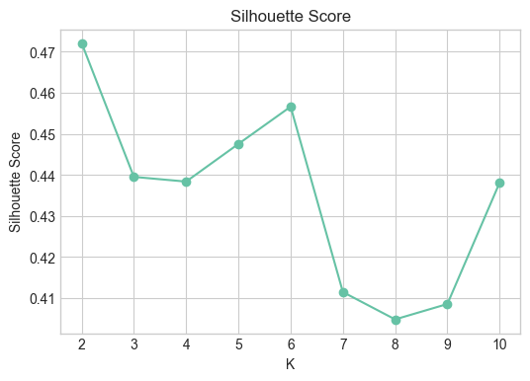
Fig 3.1 – Silhouette-score validation used to justify cluster count (Week 3).
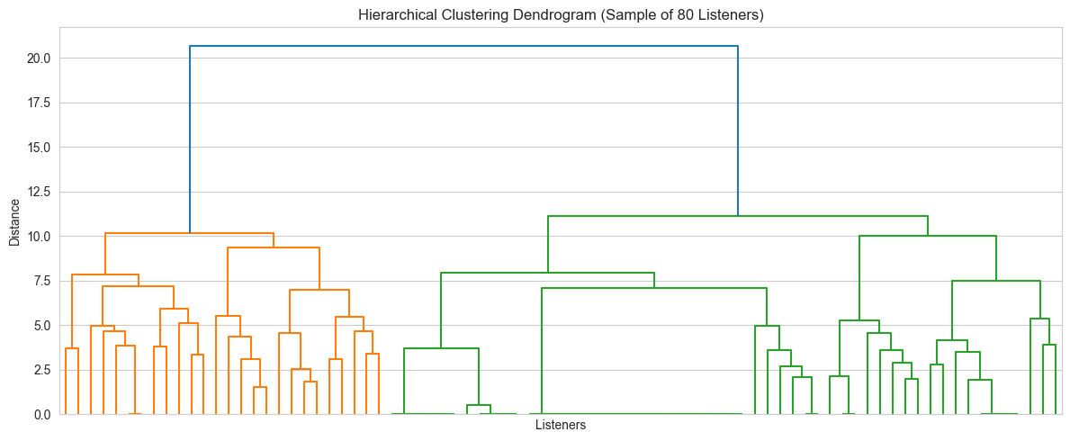
Fig 3.2 – Hierarchical-clustering dendrogram used as an independent check on the Week 4 K-Means solution.
Chapter 4 – Results and Discussion
4.1 Insights from Weekly Projects
- Week 1 (Phishing): a small number of brands — led by Allegro and the IRS — absorb a disproportionate share of phishing attempts, and phishing URL length is a highly right-skewed, potentially useful detection feature.
- Week 2 (COVID-19): the four studied countries show meaningfully different vaccination rollout speeds and average coverage, with Japan leading and India trailing on the averaged metric — a reminder to be careful about which time window a cross-country comparison actually reflects.
- Week 3 (Mall Customers): four clean, business-interpretable customer segments emerged from just two features (age, spending score), showing that simple, well-validated clustering can still produce directly actionable marketing personas.
- Week 4 (Music Listeners): a more rigorous pipeline — dimensionality reduction, hyperparameter search, and cross-validation with a second clustering method — produced eight statistically robust and musically coherent listener segments, demonstrating that added methodological rigor pays off in confidence, not just accuracy.
- Week 5 (Sentiment Analysis): a moderate-accuracy model (73.6%) hid a much more specific and useful insight — low recall on positive sentiment — reinforcing that a single aggregate metric can obscure a model's real, actionable weaknesses.
- Major Project (Fraud Detection): the most important insight of the internship — a technique's benefit (synthetic data augmentation) can be dramatic or negligible depending entirely on how much real data already exists, discovered only because both the default result and a fairer, matched-threshold comparison were examined.
A common thread across all six projects is that the most valuable insight rarely came from the headline metric alone — it came from looking one level deeper: which specific brands, which specific country, which specific misclassified review, which specific operating threshold.
4.2 Skills Gained
This internship built and strengthened the following technical and professional skills, progressively across the six weeks:
- Data cleaning and exploratory analysis on real, imperfect, publicly sourced datasets (Weeks 1–2).
- Unsupervised learning — feature scaling, K-Means clustering, and statistically justified cluster-count selection (Week 3), extended to dimensionality reduction, hyperparameter tuning, and multi-method validation (Week 4).
- Deep learning for natural language processing — building, training, and rigorously evaluating a neural network in TensorFlow/Keras (Week 5).
- Generative AI for tabular data and rigorous, leak-free experimental design (Major Project).
- Data visualization — selecting the right chart type for the analytical question, from simple bar charts through to t-SNE embeddings and dendrograms.
- Technical communication — producing a structured notebook, presentation, and written report for every project, culminating in this consolidated internship report.
Chapter 5 – Conclusion

5.1 Overall Learning Outcomes
The internship at Global Next Consulting India Pvt. Ltd. provided a structured, progressively challenging path through the data science and machine learning workflow — from foundational data cleaning and exploratory analysis, through unsupervised segmentation of increasing sophistication, to deep learning for text and generative AI for tabular data.
Each week's project used a different real-world dataset and a different primary technique, but all six shared a common discipline: verify data quality before analysis, choose visualizations that answer the actual question being asked, and evaluate results honestly rather than stopping at the first favourable number. The Major Project's scarcity-dependence finding — that synthetic data augmentation helps dramatically under severe data scarcity but only marginally otherwise — was possible only because that same discipline of rigorous, multi-angle evaluation was applied consistently throughout the internship.

5.2 Applications of Work
The techniques and findings from this internship extend naturally to further work:
- Cybersecurity: the Week 1 brand and URL-length analysis could feed directly into an automated phishing-URL classifier.
- Public Health: the Week 2 vaccination-trend methodology generalizes to tracking any rollout metric across regions or time.
- Retail & Marketing: the Week 3 and Week 4 segmentation pipelines apply directly to customer relationship management and personalized recommendation systems.
- Content Moderation & Feedback Analysis: the Week 5 sentiment model, with the identified recall improvements applied, generalizes to product-review or support-ticket triage.
- Fraud and Risk Analytics: the Major Project's leak-free, scarcity-aware augmentation methodology applies to any rare-event detection problem — insurance fraud, anti-money-laundering, or credit risk.
Internship Certificate
SUMMARY
The internship provided in-depth and practical exposure to various data analysis, machine learning, and generative AI techniques, enabling hands-on experience with tools such as Python, Pandas, Scikit-learn, TensorFlow/Keras, and Matplotlib/Seaborn. Each week focused on solving a real-world problem through structured data workflows — from data collection and preprocessing to modelling, evaluation, and reporting.
Across the six projects, the work covered a wide spectrum of analytical domains:
- Week 1 (Phishing Incident Report Analysis) – Analyzed a real PhishTank feed of 63,956 phishing URLs using Python, applying data cleaning and deduplication to identify the most-impersonated brands and characterize URL-length patterns for early threat intelligence.
- Week 2 (COVID-19 Vaccine Efficacy Trends) – Analyzed vaccination trends across India, the US, Brazil, and Japan using Python, cleaning multi-country time-series data through forward/backward-fill and feature engineering, and visualizing coverage trends, averages, and correlations.
- Week 3 (Age vs. Spending Cluster Analysis) – Performed customer segmentation using Python by cleaning and scaling data, applying K-Means clustering validated with the Elbow Method and Silhouette Score, to identify four actionable customer personas by age and spending behaviour.
- Week 4 (Music Listener Segmentation) – Analyzed Last.fm listening data for 1,381 users using Python, applying PCA, t-SNE, and hyperparameter-tuned K-Means (cross-validated with hierarchical clustering) to segment listeners into eight distinct music-taste groups.
- Week 5 (Movie Review Sentiment Analysis) – Built and trained a TensorFlow/Keras Artificial Neural Network using text vectorization, embedding layers, and dropout regularization to classify real IMDB movie reviews as positive or negative, reaching 73.6% test accuracy.
- Major Project (Fraud Detection Using Synthetic Transactions) – Built an end-to-end fraud detection pipeline using Python by integrating the genuine Kaggle Credit Card Fraud dataset with a Gaussian Copula generative model to synthesize additional fraud transactions. Applied Random Forest classification, leak-free evaluation, and matched-threshold analysis to identify when synthetic augmentation genuinely improves detection, with insights visualized through Matplotlib and Seaborn.
Through these projects, both technical and analytical competencies were developed — including statistical reasoning, unsupervised learning, deep learning, and generative AI. The internship strengthened the ability to transform raw, real-world data into actionable insights, and to evaluate machine learning results rigorously rather than at face value.
Overall, this journey has been instrumental in bridging theoretical learning with industry applications, fostering confidence and readiness for professional roles in the field of data science and machine learning.
.
REFERENCES

1. PhishTank — community-verified phishing URL database (Week 1).
2. Our World in Data — COVID-19 vaccination records by country (Week 2).
3. Mall Customer Segmentation Dataset — customer demographic and spending data (Week 3).
4. GroupLens / Last.fm (hetrec2011) Dataset — listener-artist play-count data (Week 4).
5. Stanford ACL IMDB Large Movie Review Dataset — labelled movie reviews for sentiment classification (Week 5).
6. Kaggle / ULB Machine Learning Group — Credit Card Fraud Detection Dataset, obtained via a GitHub-hosted mirror (Major Project).
7. SDV (Synthetic Data Vault) & Copulas Documentation — Gaussian Copula and CTGAN-class generative model reference.
8. Scikit-learn Documentation — clustering, classification, and evaluation-metric reference used across all projects.
9. TensorFlow / Keras Documentation — neural network architecture and training reference (Week 5).
10. Python.org — Pandas, NumPy, Matplotlib, and Seaborn documentation.

